Kubernetes Task-09
1.Execute the steps shown in the vedio.
We cannot upgrade Kubernetes from 1.26 directly to 1.28.
We must do it in two steps: 1.26 → 1.27 → 1.28.
Here the important thing to observe is that Kubernetes is using is 1.34 Version. So it is already using this version we cannot jump back, so we’ll try to continue to change the version from 1.34.11 to 1.3.12

Step 1. Check the current cluster
Run on the master/control-plane:
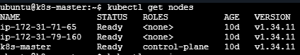

kubectl version
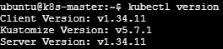

Check the existing kubeadm version
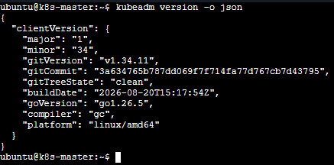

kubectl get pods -A
Make sure the cluster is healthy before starting
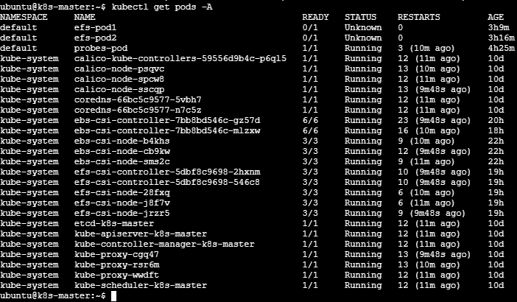

Step 2: Unhold kubeadm and Install the latest version
During the Kubeadm cluster installation process, you would have hold the kubeadm installation to prevent upgrades.
Now we need to unhold kubeadm.
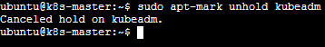
Check the available latest Kubeadm version using the following command.
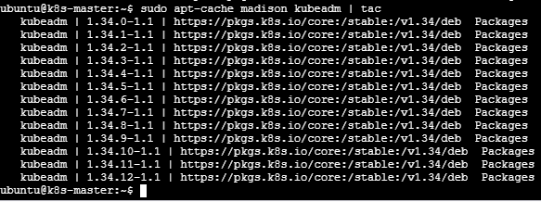
The latest version is 1.34.12-1.1. Update and install the latest version using the following command. Replace the version number you get from the output.
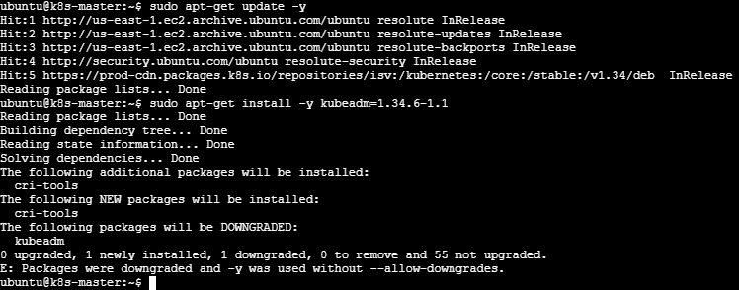
Hold kubeadm package.
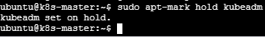

Step 3: Decide on the upgrade version
We can get the list of available kubernetes version using the kubeadm upgrade plan.
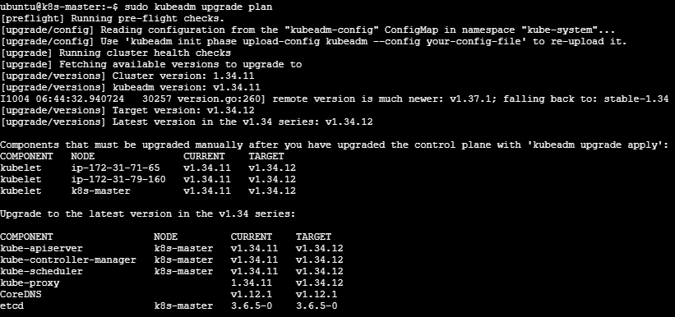

Step 4: Apply Kubeadm upgrade
Update and install Kubeadm to 1.34.12-1.1
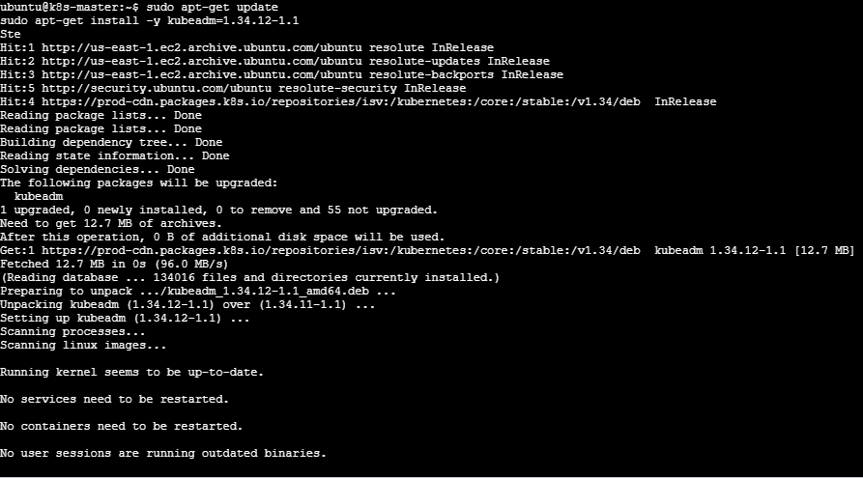
Verify:
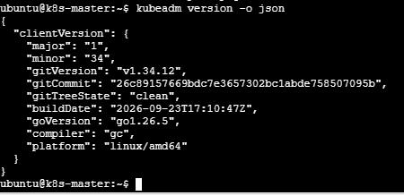

Step 6: Drain the Node to evict all workloads.
To apply the upgrade we need to evict all the workloads except daemon-sets using the following command. Replace controlplane with your controlplane node name.

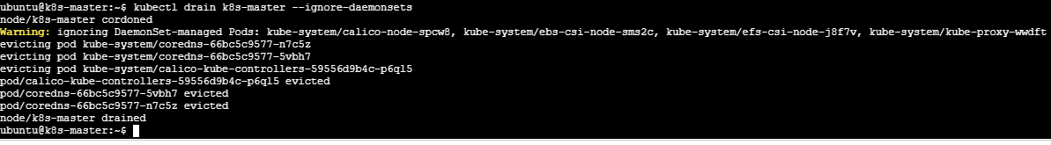
Step 7: Upgrade Kubelet and Kubectl.
Update packages:
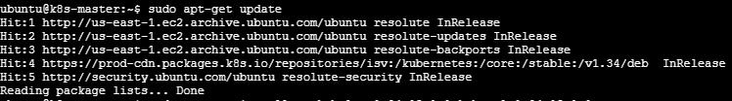
Install 1.34.12-1.1 version for Kubelet and Kubectl.
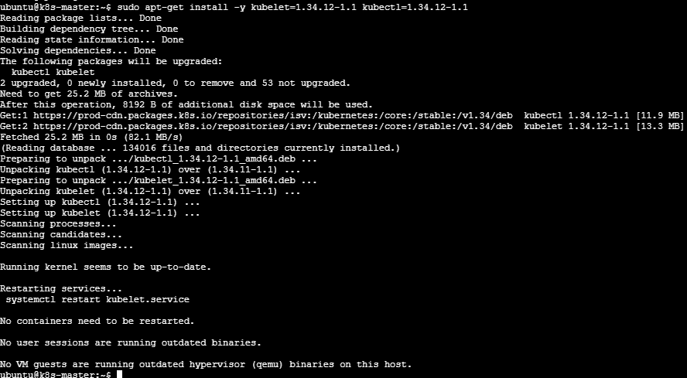
Hold Kubelet and kubectl.
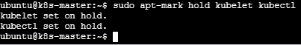
Restart the services.
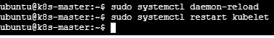

Step 7: Uncordon the Node and Verify the Node Status
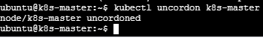
Verify the node status and version using the following command.
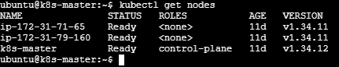

Upgrade Worker Nodes

Step 1: Unhold Kubeadm and Install Required Version
Install the required version of Kubeadm on worker nodes. Install 1.34.12-1.1version.
1.Unhold Kubeadm
On worker1:
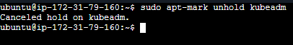
On worker2:
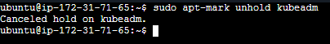
2. Update and Install Kubeadm version to 1.34.12-1.1
On worker1:
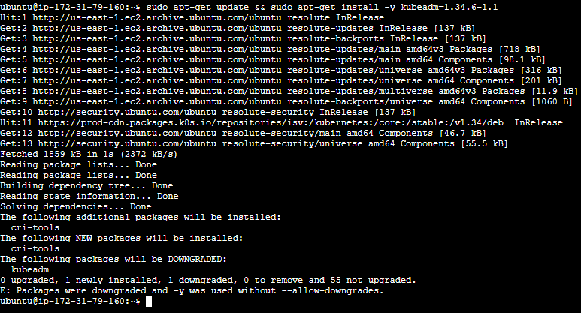
On worker2:
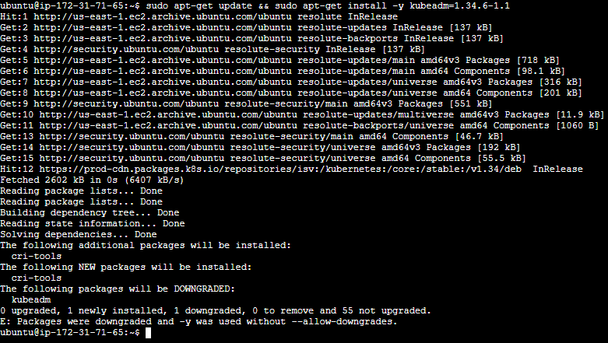
Now again hold kubeadm:
On worker1:
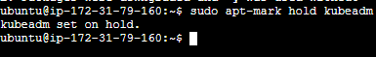
On worker2:
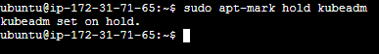
Step 2: Upgrde Kubeadm
As we are running the following command on worker nodes, it skips all the steps required for the master and update only kubelet configuration required for a worker node.

On worker1:

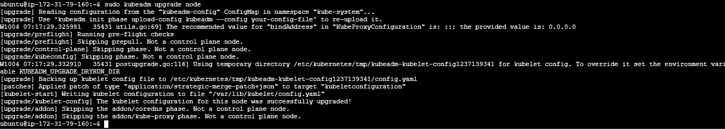

On worker2: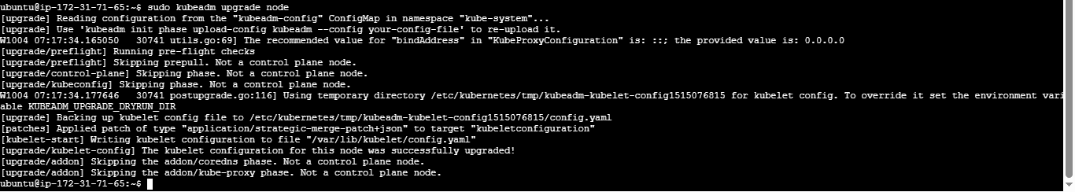
Step 3: Drain the Node
Evict all the pods on the worker node by draining it. Replace node01 with your worker node name. Execute this command from terminal where you have kubectl access i.e Master.

If pods are using local storage, you might get the error. This is mostly occur in vagrant setup. In CKA exam, you will not probably face this issue.
To rectify that issues, you need to add the --delete-emptydir-data as well.

For Node1 and Node 2

Step 4: Upgrade Kubelet & Kubectl

Unhold Kubelet and Kubectl:
On worker1

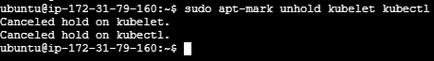
On worker2:

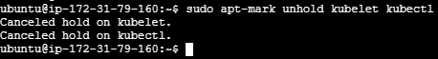

Update packages:
On worker1:
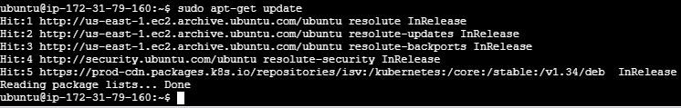
On worker2:
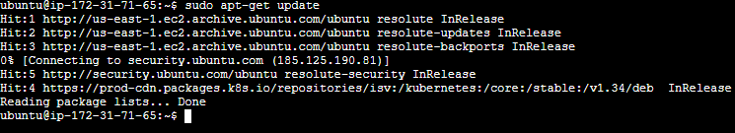

Install Kubectl and kubelet version 1.34.12-1.1

On worker1:
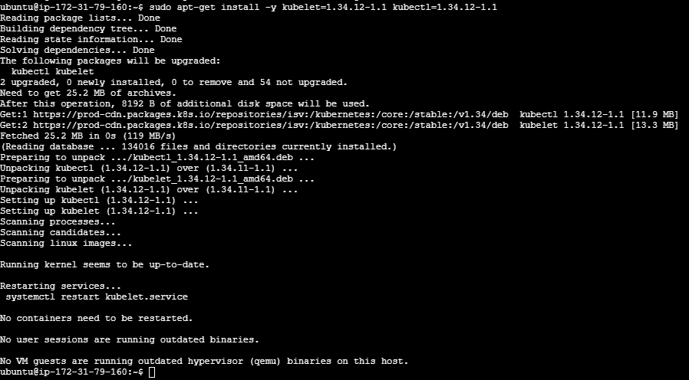

On worker2:
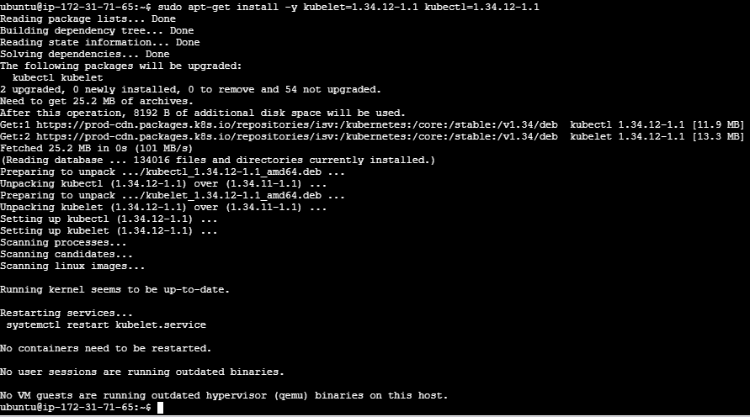

Hold worker 1 and worker2:
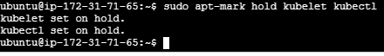
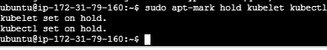

Step 5: Uncordon worker node

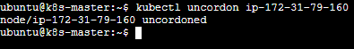
Verify Cluster Upgrade
Now that we have upgraded the control plane node and the worker nodes, lets verify if the cluster is upgraded and working as expected.

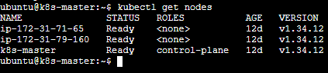
From the control plane node, you can use any one of the following kubectl commands to check the status of all the cluster components.

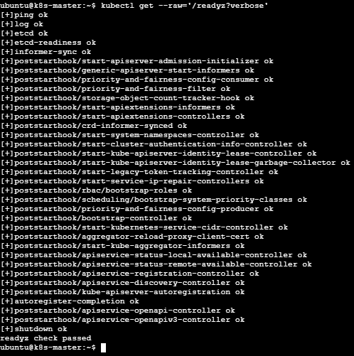
Also, check if all the kube-system control node pods are running.

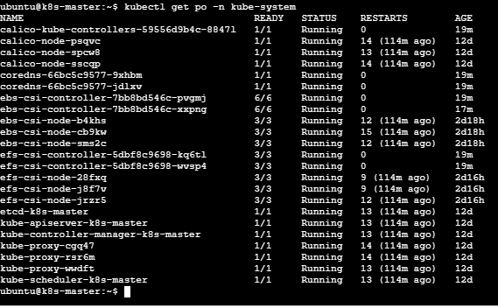

Part 1: Kubernetes Ingress with Minikube
Step 1: Check Minikube
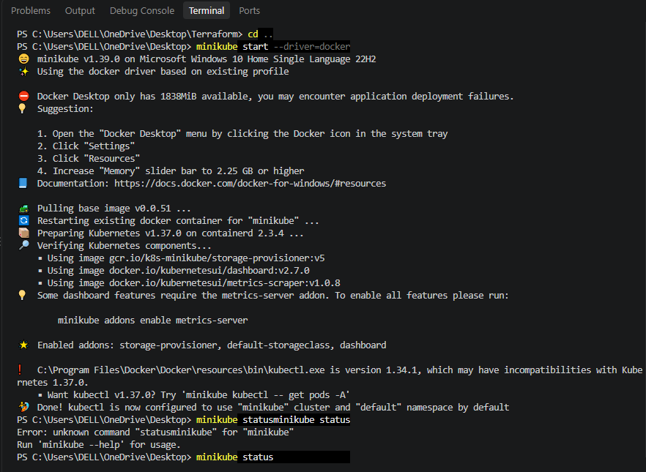
Check whether Minikube is running.
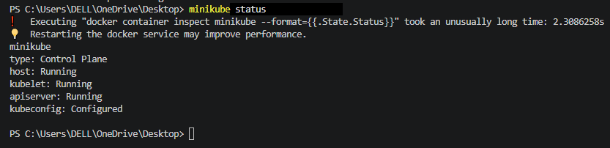

Step 2: Check existing Kubernetes resources
Check pods, services and ingress
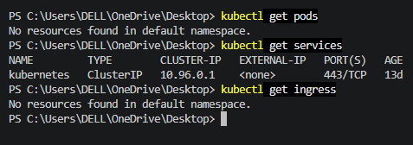

View deployment YAML
Create deployment

2. Upgrade k8s cluster from 1.26 to 1.28 Version. Note: Document to upgrade cluster. https://devopscube.com/upgrade-kubernetes-cluster-kubeadm/

Step 1 — Check the current cluster
On master:

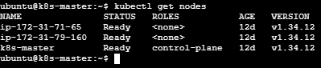
Then check the three Kubernetes components:
Kubeadm version
Kubelet version
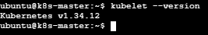
kubectl version --client
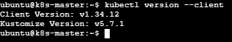

Part 1 — Upgrade Control Plane
Step 2 — Check available kubeadm versions
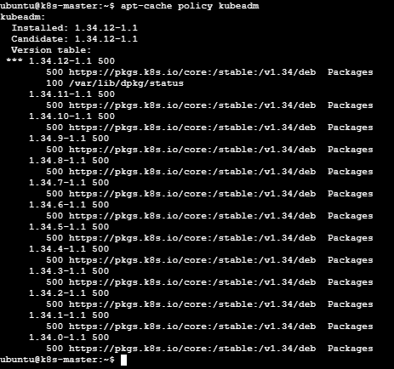
As we want to upgrade it from 1.34 to 1.35

Change repository from 1.34 to 1.35 and verify the repository:

Step 3: Update package information

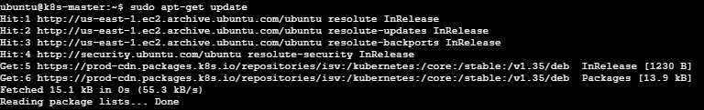

Check available kubeadm versions
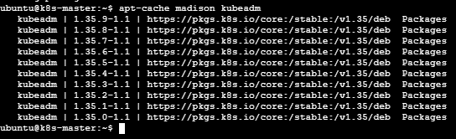

Step 4 — Unhold kubeadm

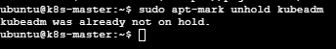

Install kubeadm=1.35.0-1.1
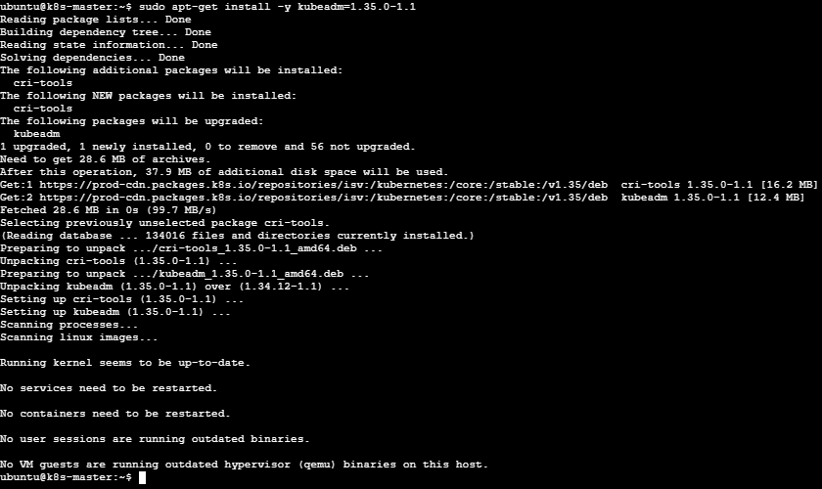

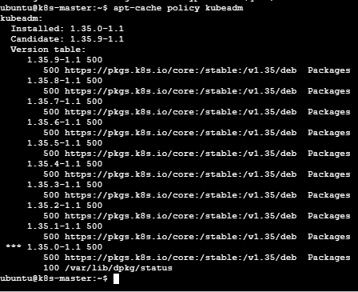

Hold kubeadm:
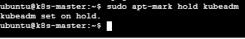
Check kubeadm version

Part 2 — Check Upgrade Plan
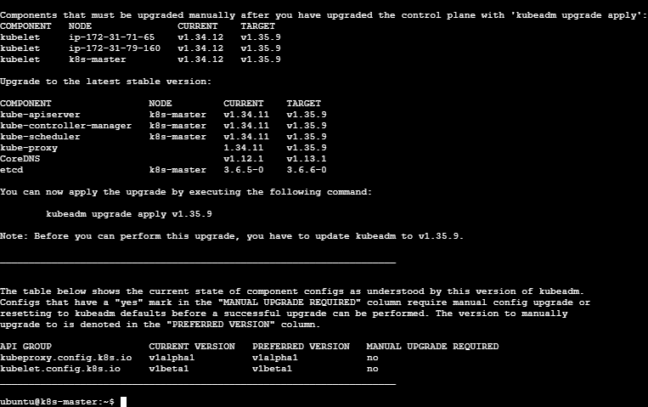

Part 3 — Upgrade the Control Plane

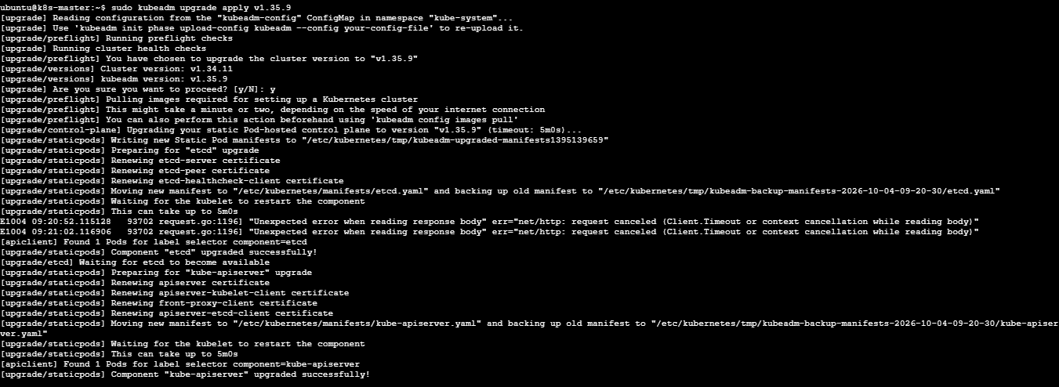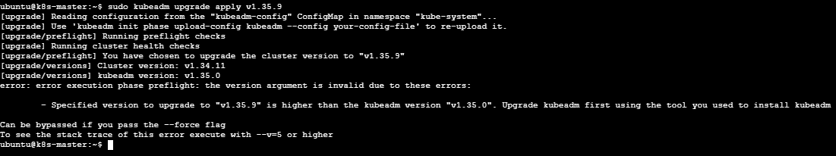

Part 4— Upgrade kubelet and kubectl on Master

Unhold kubelet and kubectl
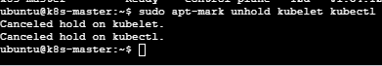

Install v1.35.9
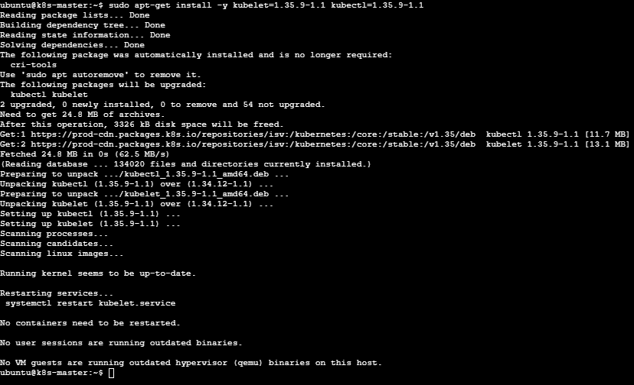
Hold kubectl and kubelet
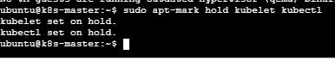

Restart kubelet
Restart and check the status of Kubelet
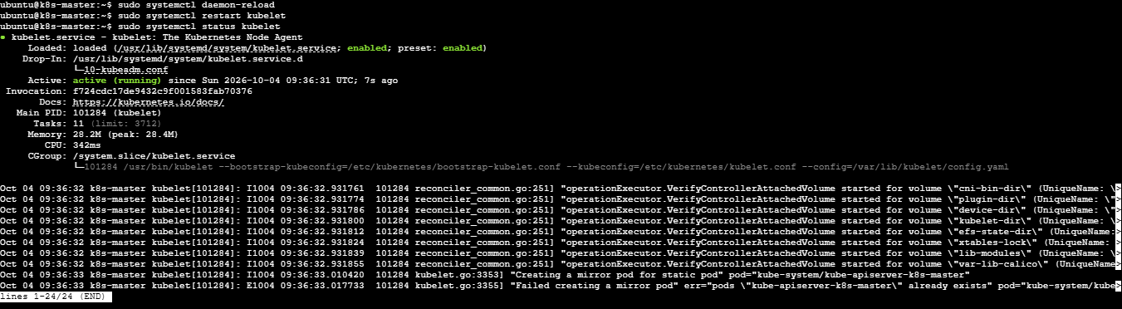

Verify master
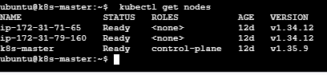

Part 4 — Upgrade Worker 1
Drain worker from master
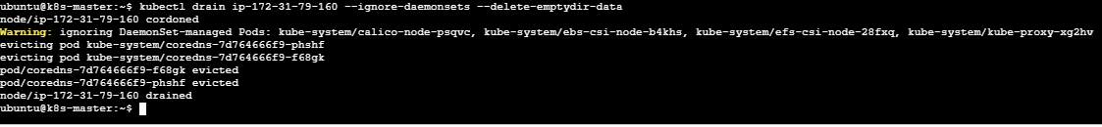
Upgrade kubeadm on worker
On worker1
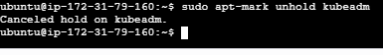
On worker2
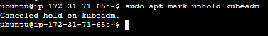
Check the current repository
As its showing v1.34, replace it with the v1.35 repository:
On worker1
On worker2

Update APT

On worker1
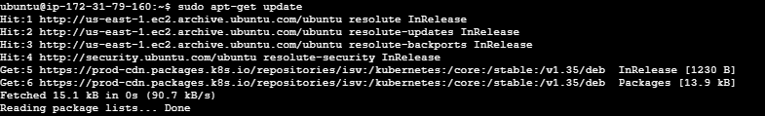

On worker2
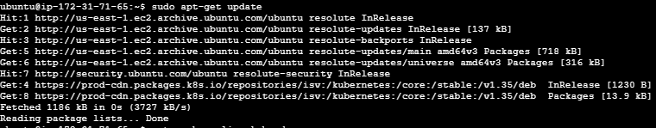

Confirm kubeadm 1.35.9 is available

On worker1
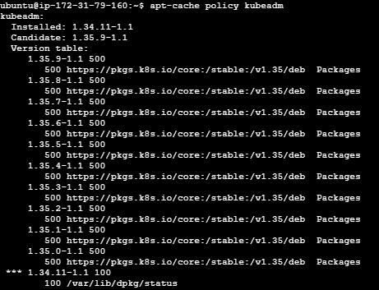

On worker2
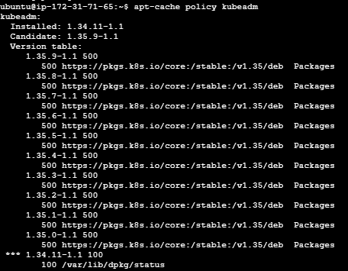

Install kubeadm

On worker1

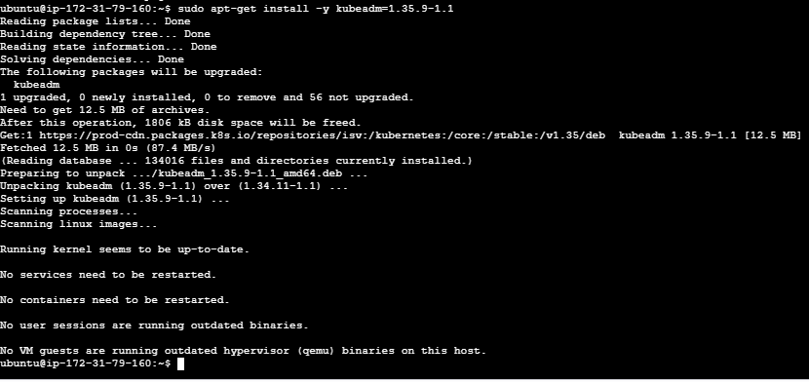

On worker2
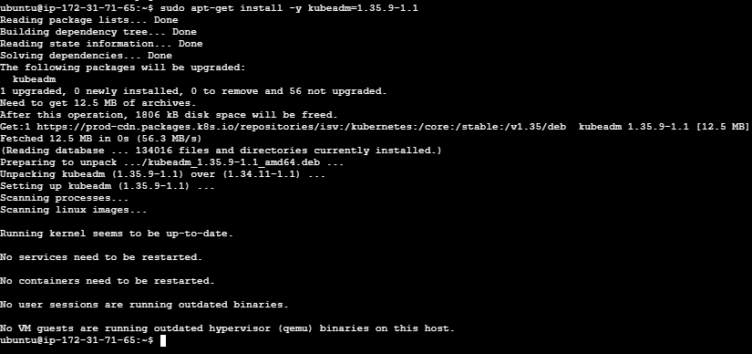

Hold Kubeadm on both workers

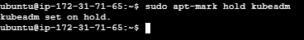

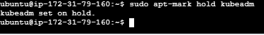

Verify Kubeadm version on both the workers

Step 15: Upgrade the worker node

On worker1
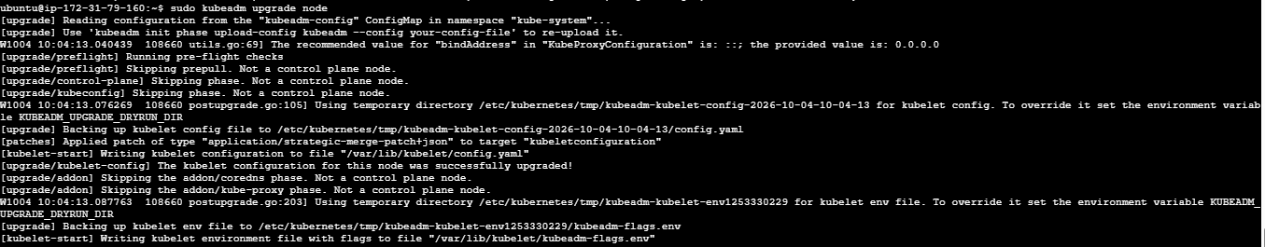

On worker2
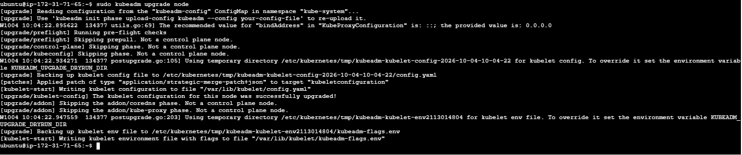

Step 16: Upgrade kubelet and kubectl

Hold both Kublet and kubectl
On worker1

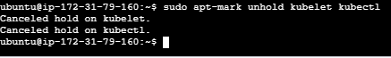

On worker2

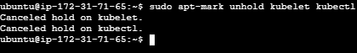
Install Kubectl and Kubelet at exactly version 1.35.9:
On worker1
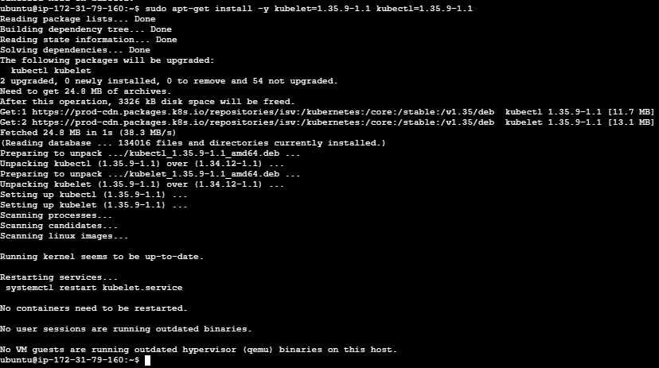
On worker2:
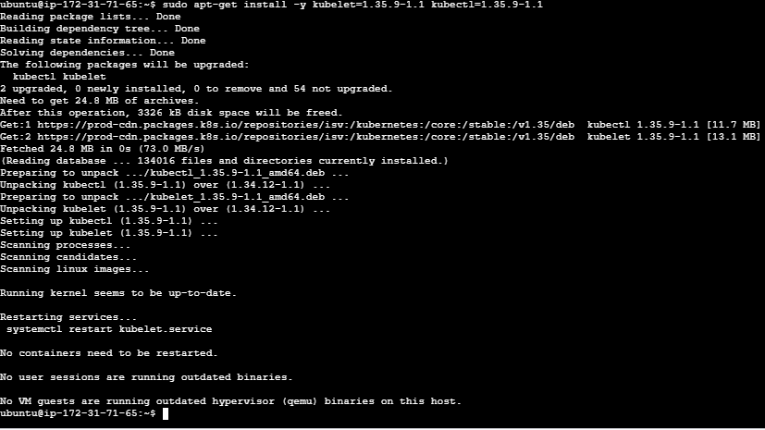
Again Hold both kubelet and kubectl on both the workers
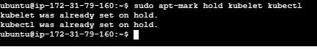
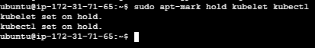
Restart: Kubelet on both the workers
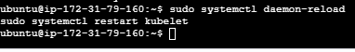

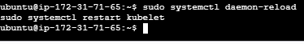
Step 17: Uncordon both worker1 and worker2 on master
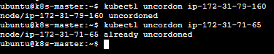

Step 21 — Final verification
All three are showing the updated version
Also check system pods to be running:
